Project Plan

<Project Name>

Lachlan Dietrich | Rokhan Khattak | Arsalan Hanif

Table of Contents

1.0 Introduction 3

1.1 Problem Background 3

1.2 Scope 3

1.3 Document contents 3

2.0 Work Breakdown Structure 4

3.0 Activity Definition & Estimation 5

4.0 Gantt Chart 6

# Introduction

## Background

To undertake any level of analysis regarding a dataset, appropriate data visualisation and analysis tools are essential for the users. An example such as Microsoft’s Excel demonstrates possible tools that could be applied and offers a basis for what possible data visualisation and functionalities may be needed. Functionality may include data updates and selections, both being essential functions required by datasets of any scale or sort. An example of this could be found in a construction business, where multiple data fields are required to possess information such as costs, employee availabilities, timelines, and dates simultaneously. Therefore, to ensure effective development, a development timeline is important to clearly outline prior initiation, alongside a timeline that tracks and records progress made to prevent possible data losses or deletion.

## Scope

The goal of the project is to develop a dataset analysis tool that can extract, inspect and analyse data from a prescribed dataset. The prescribed dataset holds Sydney Airbnb records including a variety of listings, calendar events including availabilities, reviews, and neighbouring houses/properties. The tool is required to report information of the dataset’s listings, produce diagram outputs and conduct data retrievals for keywords using a user-selected period. The tool is also required to allow selection of customer comments regarding cleanliness.

These criteria must be necessitated, as they can also be utilised to accommodate for complex datasets alongside the Sydney Airbnb dataset, ensuring consistent data processing that can be considered reliable even beyond the scope of the given dataset. This software should be facilitated for any user, accommodating to various factors such as dataset complexity, hardware constraints and possible user error.

## Document contents

*Include some background information about the problem, the scope and what this document will contain.*

# Work Breakdown Structure

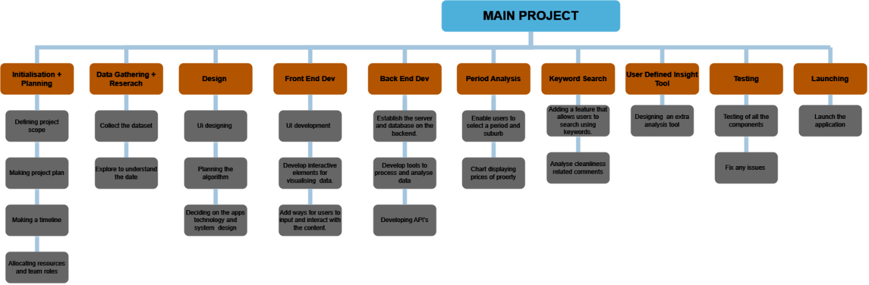

# Activity Definition & Estimation

The following activities are required to be completed for this project:

1. Initialisation & Planning ***(5 days)***
   1. Defining the project scope
   2. Making and documenting a project plan
   3. Making a development timeline (Gantt Chart)
2. Data Gathering & Research ***(1 day)***
   1. Collect the dataset
   2. Explore the dataset to understand the data
3. Design ***(7 days)***
   1. Plan and draft the UI design
   2. Planning the algorithm
   3. Deciding on the app’s technology and system design
4. Front End Dev ***(14 days)***
   1. Develop the UI
   2. Develop interactive elements for visualising data
   3. Add ways for users to input and interact with the content
5. Back End Dev ***(14 days)***
   1. Establish the server and database on the backend
   2. Develop tools to process and analyse data
   3. Develop APIs
6. Period Analysis ***(5 days)***
   1. Enable users to select a period and suburb
   2. Develop chart displaying tools for property prices
7. Keyword Search ***(5 days)***
   1. Adding a feature allowing users to search keywords
   2. Analyse ‘cleanliness’ related comments
8. User Defined Insight Tool ***(5 days)***
   1. Design an extra analysis tool
9. Testing ***(3 days)***
   1. Test all the app components
   2. Fix any issues
10. Launching ***(3 days)***
    1. Launch the application
    2. Review the development

The total development time, including planning, synthesising, debugging and reviewing, is estimated to be 62 days, approximately 2 months.

# Gantt Chart

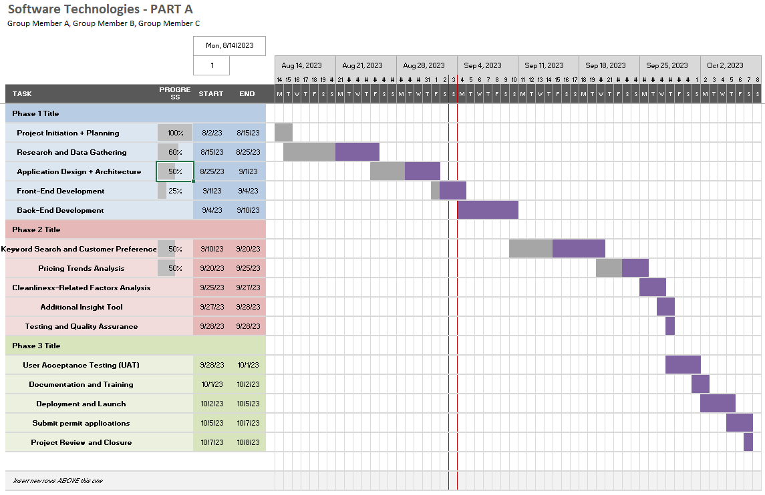

*This section should contain your Gantt chart. The items in the Gantt chart should match the activity definition from section 3. You should also submit your Gantt chart file separately.*